Active Directory Lab 06
Account Lockout Policy and User Account Recovery
Objective
The objective of this lab was to understand how Active Directory handles account lockout events after multiple failed login attempts. The lab demonstrated how to trigger an account lockout, identify the corresponding security event in Event Viewer, unlock the affected account using Active Directory Users and Computers (ADUC), and verify successful user authentication after the account was restored.

Lab Environment
Component | Details
Operating System | Windows Server (Domain Controller)
Client Machine | Windows 11
Virtualization | VMware Workstation / VirtualBox
Domain | mydomain.com
Tool Used | Active Directory Users and Computers (ADUC), Event Viewer

Step 1: Triggering an Account Lockout
The Windows 11 client machine was used to simulate multiple failed authentication attempts. The john.doe domain account was selected, and incorrect passwords were entered repeatedly until the configured account lockout threshold was reached.
After multiple unsuccessful login attempts, the system displayed a message indicating that the account had been locked due to security policy restrictions.
This exercise demonstrated how Active Directory protects user accounts from password guessing and brute-force attacks by temporarily locking compromised accounts.
Result
The john.doe user account was successfully locked after exceeding the allowed number of failed login attempts.

Screenshot 1: Account Lockout Message on Windows 11
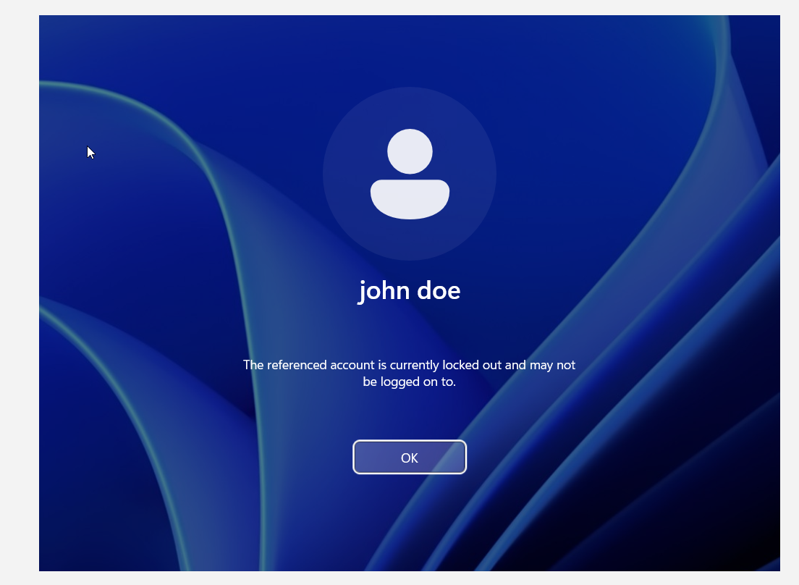
Step 2: Investigating the Lockout Event
After the account lockout occurred, Event Viewer was opened on the Domain Controller to investigate the security event. The Security log was filtered using Event ID 4740, which records account lockout events in Active Directory.
The event log provided detailed information, including:
- Locked user account
- Caller computer name
- Time of the lockout
- Event ID (4740)
These details confirmed both the affected user account and the source system responsible for the failed authentication attempts.
Result
The account lockout event was successfully identified and verified through Event ID 4740 in the Security log.

Screenshot 2: Event Viewer Showing Event ID 4740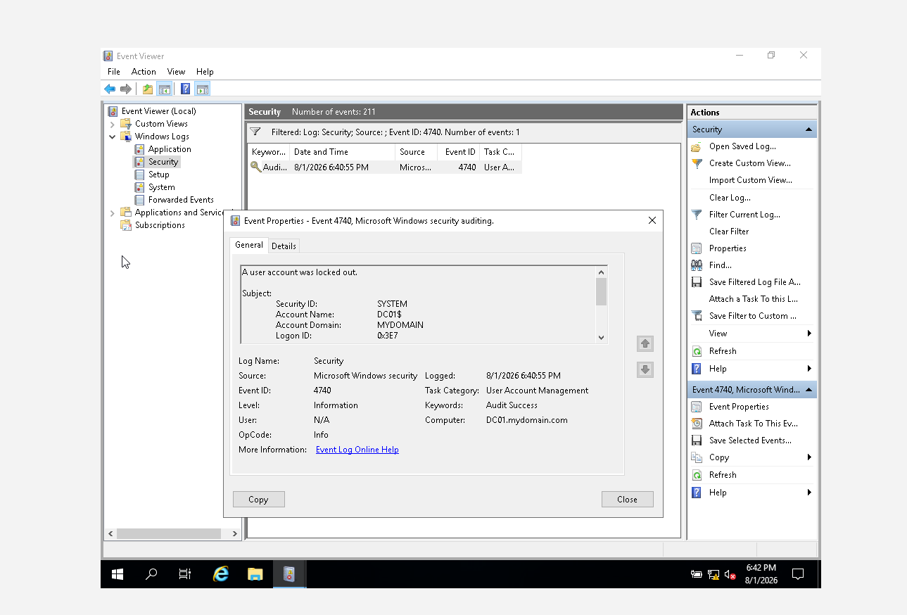

Step 3: Documenting the Lockout Event
The Event Viewer details were reviewed and documented by capturing a screenshot showing the lockout event information. The screenshot included the locked account name, caller computer, and event details for future reference and reporting.
Result
The account lockout event was successfully documented.

Step 4: Unlocking the User Account
The locked user account was recovered using Active Directory Users and Computers (ADUC). The properties of the john.doe account were opened, and the Account tab was accessed. The Account is locked out option was cleared, restoring access to the user account.
This process demonstrated how domain administrators can quickly recover locked user accounts without resetting passwords.
Result
The john.doe account was successfully unlocked through Active Directory Users and Computers.
Screenshot 4: Unlocking the User Account in ADUC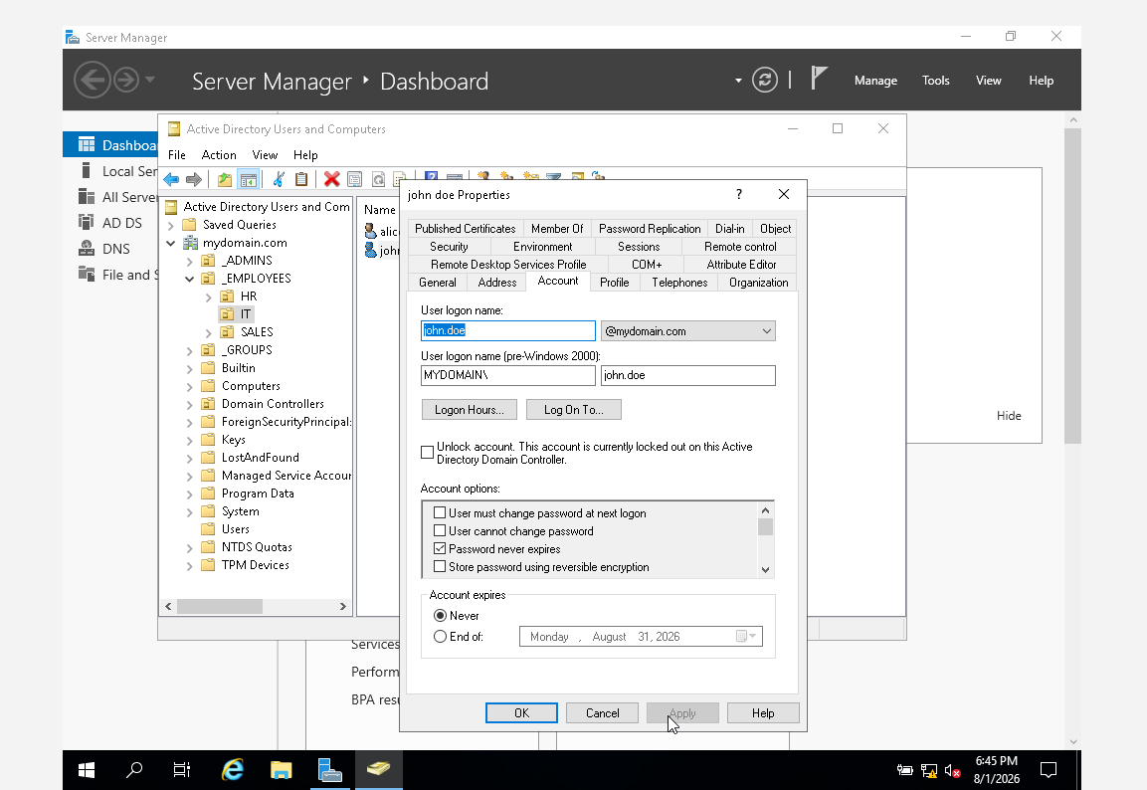

Step 5: Verifying User Authentication
After unlocking the account, the Windows 11 client machine was used to log in again using the correct credentials for john.doe.
The authentication completed successfully, confirming that the account had been restored and that the lockout condition had been removed.
Result
The user successfully authenticated with the correct password after the account was unlocked.
Conclusion
This lab demonstrated the implementation and management of the Active Directory Account Lockout Policy. Multiple failed authentication attempts resulted in the successful lockout of a user account, illustrating how Active Directory protects against unauthorized access and brute-force attacks. The associated security event was identified using Event Viewer (Event ID 4740), allowing the source of the lockout to be investigated. The account was then successfully unlocked using Active Directory Users and Computers, and normal user authentication was restored. This exercise provided practical experience in monitoring security events, responding to account lockouts, and performing common administrative recovery tasks within an enterprise Active Directory environment.

